**HOW TO MAKE AMALA THE YORUBA WAY**

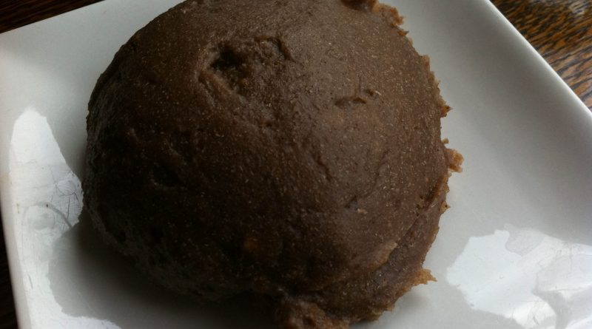

If you hail from the western parts of Nigeria or stay within that region, it’s most likely you have a fondness for amala. Most people that hail from the western part of Nigeria often have amala as their best food while visitors often appreciate it a lot.

* In some cases, some visitors upon eating it a few times, choose it as their best meal. It’s a famous Nigerian delicacy made from yam flour or cassava flour. It’s extremely difficult to visit local food canteen and not see amala on the menu especially in cities like Lagos and Ibadan.
* Amala is quite easy and quick to prepare. It takes an approximate of 20 minutes to cook it. Amala could either be white or black. However, both types of amala are prepared in the same way and enjoyed by its respective lovers. Black amala is believed to last longer when consumed while white is believed to be eaten by the low class in the society.

**INGREDIENTS FOR AMALA**

* Water
* Yam flour (either gotten from yam bark or its flesh)

**AMALA PREPARATION STEPS**

* Take a clean pot and pour in some water. The amount of water depends on the quantity of amala to be paid. Carefully place pot on your cooker/stove and boil water till it reaches boiling point. As soon as the water boils, turn down the fire and gradually add the yam flour into the boiled water.

* In order to prevent lumps in the amala, make sure you do not pour the yam flour into the water while still the water is still on cooker/stove.
* Get a wooden stick and begin to turn the yam flour with it for a while, pour a little more water and return it onto the cooker/stove.
* Allow it to cook on low heat for 5 minutes in order to make it cook appropriately. At this point, you may use finger to check the texture to confirm that its neither too hard nor too soft.
* Please ensure you use clean finger. If you discover that it is too soft you may pour additional Yam flour, and if its the other way round,simply add some hot water.
* After that, ensure you stir very well until it becomes very smooth.
* Once your Amala becomes very smooth, it can be said to be ready. You may then wrap it in transparent nylon and carefully place it in a warmer, in order to keep it warm but its for immediate consumption, serve it with soup of your choice such as ewedu with stew, efo riro, egusi, okra soup, bitterleaf soup etc. and enjoy.